For the layout of the proposed intelligent traffic light control device, a model of the device based on a microcontroller with a Wi-Fi module ESP-8266 has been developed. The layout of the traffic light is based on colored LEDs: red - R314D-L, yellow - LY 2040, green - FYL-5013 UGD. The mobile control device (cloud part of the system) is implemented on the basis of a mobile device on the Android platform. The general view of the layout is presented in Fig. 1.
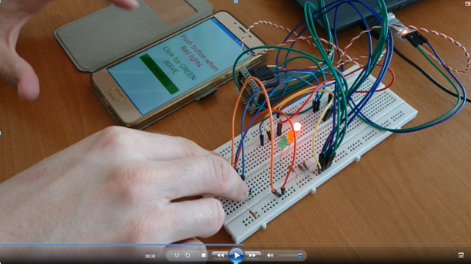
Figure 1 – Preparing to press the «green wave» mode button

Consider the principle of real-time layout. We simulate the situation that you are a representative of special services, who hurries to the call and gets into a traffic jam, which is due to the insufficient duration of the green traffic light. The proposed device simplifies all the complex problems of motorists and has the following principle of operation:
1. When the traffic light is off (red light), you turn on the "green wave" mode by pressing only one touch button on the mobile phone (Fig. 1).
2. After pressing the button, it becomes locked (press as much as you want - it does not work), but the green light does not turn on immediately, but after the cycle of red light (Fig. 2). We must expect that the end of the cycle of red light, in order not to turn everything into a car accident (not very nice to get the case of the simultaneous appearance of the intersection with vehicles traveling on the side street at a decent speed). Especially since you are a representative of special services.

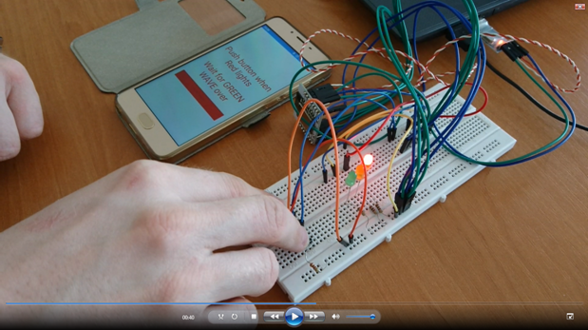

Figure 2 – The button is pressed and locked, we are waiting for an answer

3. The green light came on. Travel time in your direction is three times higher than usual. You can go to the next traffic light. (For those who do not read the specification - a separate label is displayed in red, which informs the user not to turn on the "Green Wave" mode during the "Green Wave" mode).
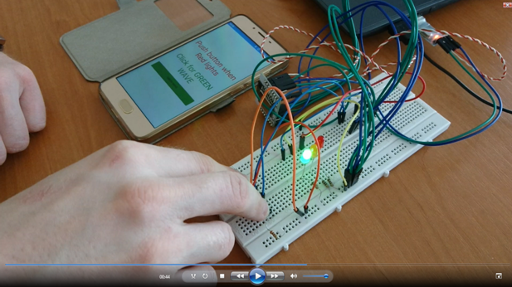

Figure 3 - The answer came, the «green wave» is working

4. We approached the next traffic light, red light again - repeat steps 1-3.
In order to demonstrate the efficiency of the project, as well as the reliability of the device photos of the layout (Fig. 1- 4) were shown specifically with the display of time intervals on the panel of the video player.
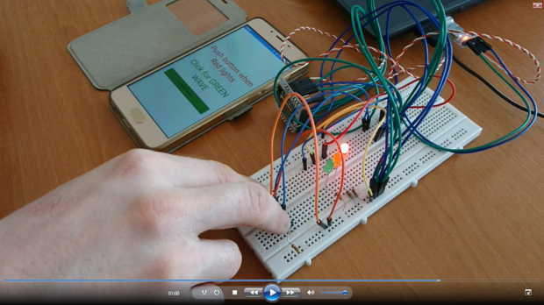
Figure 4 - The device is ready to turn on the «green wave»

